**Kronos Q&A Session – June 14, 2023**

**UPDATES FROM PREVIOUS SESSION**

* Kong Vang worked with Kronos to expand the number of displayed “activities” (org/project codes) from 4 to 10!
* Jeff Quamme provided a demo on how he uses the “copy” function to copy all “activities” from one day to another.   
  + 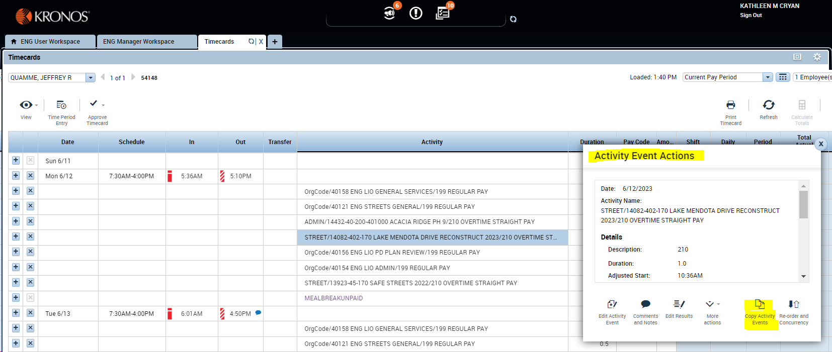To copy all activities from a prior day, click on one row of your time allocated on that day and then right click. This will display the “Activity Event Actions” dialog box.
  + Click on “Copy Activity Events”. This will display the “Copy Activity Event” dialog box.
  + 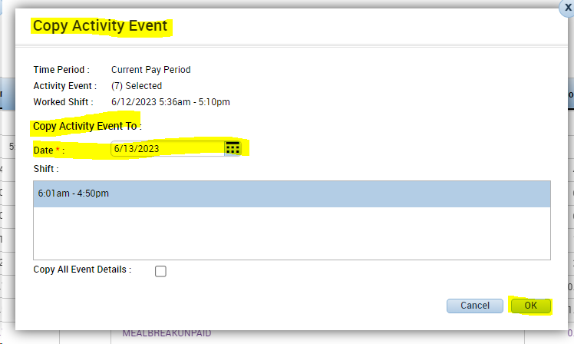Select the “Date” you want to copy the activities to and click “OK”.
  + Note that this will copy all activities including the Pay Code and Hours from the prior date. You will need to update Pay Code and Hours to accurately reflect your time on the date you copied this info to.
  + You can use the search functionality to find a different pay code or to add a different org code or project. You can also delete rows for projects you did not work on for the date you copied to.

**QUESTIONS & ANSWERS FROM TODAY’S SESSION**

* **Why do I need to enter */*org/project name or number*/* to search for an activity?**
* Each activity consist of three segments – Fund/Project # and Name/Paycode. Entering the * as a wildcard displays all value for that specific segment. Entering a portion of the project number and/or name with * on both sides filters the displayed values to those that include the values you entered.
* **What are the “red bars” next to my in and out time entries?**
* Kronos refers to these as “Exception Indicators” and uses these to flag exceptions to your schedule. If you hover over the “red bar” it will display the specific exception. A list of exceptions and what they mean is provided below:
* Unscheduled — An employee punches in on an unscheduled day.
* Long Interval — An unusually long time between an in-punch and an out-punch. The rounded time between the punches is used to compute this exception. If the time between the in-punch and the out-punch is equal to or greater than the long interval, the long exception appears.
* Short Shift — When rounded shift lengths are less than or equal to the short shift.
* Very Early In — Employee punches in before the scheduled start time, at or before this amount. For example, the scheduled start is 7:00 a.m. and the Very Early amount is :30. Punches at 6:30 a.m. and earlier trigger the Very Early exception.
* Early In — Employee punches in before scheduled start time.
* Late In — Employee punches in after scheduled start time.
* Early Out — Employee punches out before scheduled end time.
* Late Out — Employee punches out after scheduled end time.
* Very Late Out — Employees punches out after scheduled end times, and at or after the Very Late out amount. For example, the scheduled end is 5:00 PM and the Very Late exception is :30. Punches at 5:30 PM and later trigger the Very Late exception.

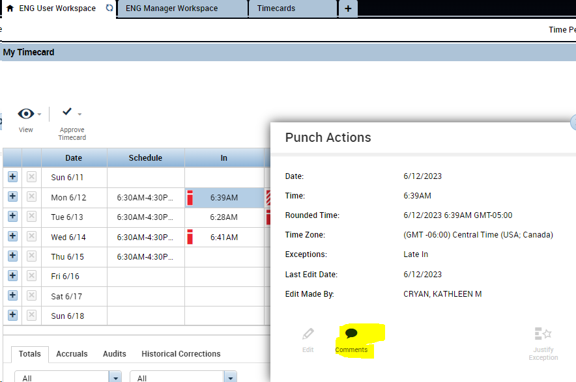You or your supervisor can add a comment to any exception by right-clicking on the time stamp and clicking “Comment”.

* **If I want to use floating holiday and vacation to cover my time off on a given day do I need to submit 2 requests?**
* Yes.
* **How do I submit a request for time off that would include a weekend or holiday?**
* If you are entering a request for time off that spans a weekend or holiday your will need to enter separate requests for the days before and after the weekend and/or holiday. If you do not Kronos will interpret your request as including the weekend or holiday.
* **How do I access where I make time off requests?**
* Select “My Calendar” from the far right panel.

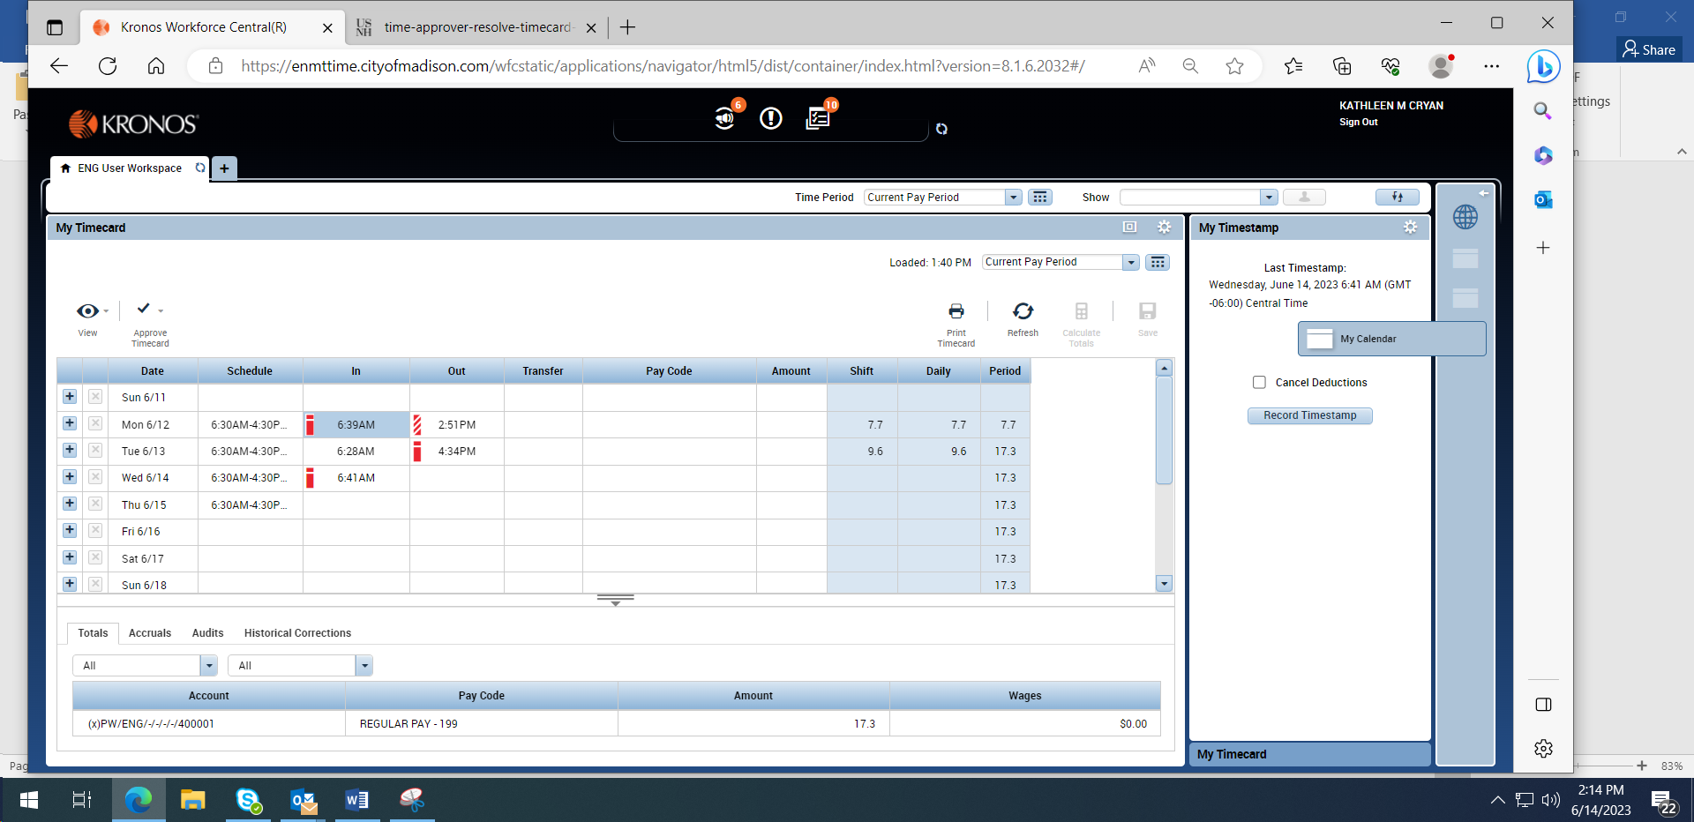

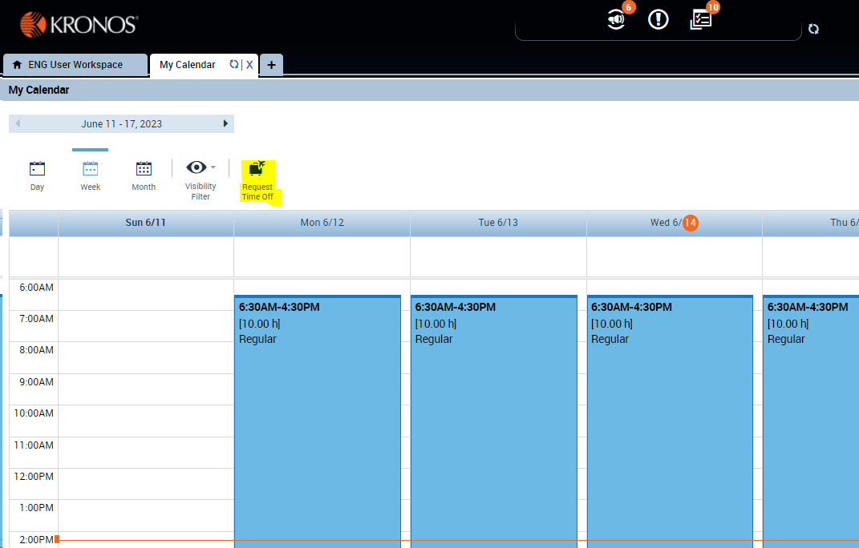This will display your calendar. Click on “Request Time Off” to enter and submit your request.

* **My schedule is 8:30 AM to 5 PM. I had an approved vacation request for one day from 8:30 AM to Noon. How do I account for my time worked that afternoon?**
* Enter your actual start and end times for that afternoon. If you actually worked more than 6 hours Kronos will automatically deduct your unpaid meal break. If you worked less than 6 hours Kronos will not deduct your unpaid meal break.
* **Can I enter paid leave at the end of the pay period to make up any missing hours?**
* Vacation, floating holiday, and comp time off are to be used at a time mutually agreeable to the employee and the supervisor. That means you should have prior approval from your supervisor to work fewer than your scheduled hours. Sick leave can be taken unilaterally. Best practice is for the supervisor to enter sick leave when an employee calls or emails in that they are sick and will not be in. Requests to use sick leave for doctor’s appointments can be submitted in advance, just like a request to use other forms of paid leave.
* **Can automation be turned off to eliminate my lunch periods?**
* We cannot turn automations off due to the number and complexity of pay rules. The Engineering Division employs individuals in Comp Groups 15, 16, 20, 71 and 18. Each comp group has varying pay rules. Comp group 18 has 3 different sets of pay rules based on range. These pay rules have been configured in Kronos. Each employee is attached to a set of pay rules based on their position.
* **Can my timesheet view be changed to not display my schedule?**
* No.
* **Is it possible to view employee hours by project in the “Totals” tab?**
* We will research to see if this is possible. We will also review existing reports to see if any of them provide the requested information.
* **I was scheduled to be on vacation but ended up working for part of the time. How do I enter the time I worked? How do I adjust my vacation used?**
* You can enter your time worked while scheduled to be off the same way you would if you were working the entire day. Enter the time you started working and the time you ended each day. At the end of the pay period let Jennifer know you need your vacation adjusted. If Jennifer is not available please contact Kong or Cindy.