
Engineering Design Guidance Document

Table of Contents
Common Bid Items used on Street Construction Projects 2
Street Design Guidance 3
Street Design Information 6
Tree Planting Areas 8
Soil Boring Information 8
Functional Class Legend (ENG Map Viewer) 9
Temporary Parking Permit Program (RP3) 10
Consultant Contract Amendment & Municipal Agreements 10

Common Bid Items used on Street Construction Projects
It should be discussed with a Senior Engineer if any of these items should be removed from the project contract:
- Tack coat.
- Excavation Cut.
  - Typically calculated in Civil3D by comparing existing surface and datum surface (bottom of proposed corridor).
  - Includes asphalt pavement removal unless we are pulverizing or milling.
  - Concrete pavement removal is paid as its own item separate from excavation cut
    - Paid in addition to. Example: If excavation is 1.5’ deep and 0.5’ of that is existing concrete pavement, the depth of excavation cut is still 1.5’. The area of that existing concrete pavement is also paid under the remove concrete pavement item as well.
    - Review soil borings for ex. concrete under ex. asphalt.
  - Street undercut to be included in excavation cut item.
  - Sanitary/storm undercut to be reviewed by designer.
    - Use the undercut sanitary or storm item.
  - Include Breaker Run to backfill undercut areas.
    - Breaker run is 5” clear stone with minimal fines. Specs also call for 1' max depth for undercut.
    - See 201.2e in the City Standard Specifications: https://www.cityofmadison.com/engineering/developers-contractors/standard-specifications
  - For a new street in a farm field as part of a public works contract, there is a potential for a significant undercut to be required plus a large quantity of excess topsoil, review with a Senior Engineer.
    - Excess topsoil, if shredded, can be used for terraces and side slopes.
  - Topsoil for a typical street reconstruction project can’t be reused for terraces.
- Fabrics – include both non-woven and reinforcement for projects.
  - The geotextile non-woven is the one primarily used. Less expensive and good for separating breaker run from poor soils. The reinforcement is for added strength in poor soils or in areas with high groundwater.
- Hand form curb.
- Asphalt drive and terrace.
  - Typically, an undistributed amount to replace small portions of asphalt driveways in locations where sidewalk is replace through driveways
- Maintain residential driveway access.
- Type C inlet protection.
  - Need both types of inlet protection: fabric and rigid frame. C and D.
  - Quantity for maintaining inlet protection should be minimum twice as much as the number of inlets.
  - Erosion control limits should always be greater than construction limits unless project is extremely ﬂat. Don't forget about downstream inlets!
- Gradation No. 2 – size 1_1/4” max.
- Gradation No. 1 – size 3” max.
- Include gradation 2 under all driveways (6-Inch base), curbs (12-Inch base), and curb ramps (6-Inch base) in the quantity.
- Include 15% additional gradation 2 in the quantity.
  - Even though standard section has approximately equal thicknesses of Gradation 1 vs. Gradation 2, in practice, Gradation 2 is used considerably more than No. 1, especially under curb areas because it easier to grade
- Underdrain – see design guidance
- Utility trench patch type III, use trench feet (T.F.), not square yards (S.Y).
- Conversion of asphalt or stone quantity: SY*IN*(0.06 Tons/SY-IN) = Tons.
  - 120 LBS/SY-IN*1 Ton/2,000 LBS = 0.06 Ton/SY-IN conversion factor
- Tack Coat = 0.07GAL/SY, min. 0.05 – max. 0.1.
- Aggregate and Asphalt Conversion 2.16 Tons/CY assumes a density of 160pcf.
- Mobilization (usually 10%) & Traffic Control (provided by traffic engineering or estimated from similar projects).
- Sidewalk & curb (projects with spot replacement)
  - Add additional 20% sidewalk quantity to estimate for MG&E gas replacement work.
    - Think about increasing removal quantities when installing curb, sewer, or streetlight conduit.
- Always double check the bid item numbers, as it can vary from previous years
- Adjust Valve Box (70104) & Adjust Water Service Box (Special): If the Water Utility is not participating - these typically will get adjusted to meet the new grade of the street/sidewalk/terrace, adjustment done by Contractor and paid for under Street Account.
- Root Cutting - Curb & Sidewalk (10801/10802) = Typically good to include if there is any work around trees, include if there are any NRC (no root cut) notes on the project.
- TERRACE EXCAVATION FOR TREE PLANTING (20110) = A new item but will likely be included on all street reconstruction/resurfacings moving forward.

Street Design Guidance
- Design Engineers should be familiar and knowledgeable with the existing site in design.
  - Multiple site visits are needed.
    - Preferable to schedule at least one with City Forestry, a Park representative (if applicable), and with the utility’s designer.
    - As part of review, consider potential impacts at right-of-way boundary that may need special attention or communication, especially in locations where landings may need to be lowered for ADA curb ramps
- WisDOT Facilities Development Manual
  - https://wisconsindot.gov/rdwy/fdm/fd-11-10.pdf
    - K(value)=V²/46.5, Drive Comfort on Sag Curves.
    - Typical Deceleration Rate 11.2 ft/S^2.
    - Stopping sight distance, 3.5' eye, 2' object.
- 10% max. slope local street; 8% max. slope collector street; 6% max. slope arterial street.
- Tabletop Intersection 10' min. length, speed hump & raised crossings 6’ min length transitions
  - Transition (slope up/slope down), 7% max. slope transition target 5%-6%, if buses or larger vehicles anticipated target 5% transition.
- A minimum horizontal curve radius of 150’ is required along the street centerline.
- Proposed Driveway Slopes.
  - Max Residential 12%.
  - Max Commercial 8%.
  - Can use type ‘x’ curb to help meet these grades, but not on streets with less than 0.8% longitudinal grade (0.8%-1.0% require 8’ transitions, > 1.0% 6’ transitions; transitions longer than 6’ need to be specifically called out on plans).
- Concrete pavement Longitudinal joints - tie bars.
- Concrete pavement Transverse joints - dowel bars.
- No erosion control plan is required if the project disturbance is under 20,000 sf.
- Proposed typical terrace slope 1%-25% (target = 4%), could go min. 0.5% but would like to avoid that.
  - There are circumstances where the terrace may be above 25%.
  - Use proper restoration, such as different matting or sod, on steeper terraces.
  - When there is no possibility of lowering the curb anymore and terrace is draining towards the sidewalk, consider using shorter curb heads (5” or 4”).
- Proposed longitudinal street profile.
  - Min. profile slope 0.5%.
  - Low & high points need to be -0.5% down for a minimum of 5’, then 0.5% up for a minimum of 5’.
  - Longitudinal slope needs to be above 0.5% if street has horizontal curves (edge of pavement will be ﬂatter along the outer curve).
  - There are circumstances where the 25’ distance may be reduced.
- Try to have a max cross slope in the intersections of 5% to help pedestrian crossings.
- Avoid low points between curb ramps to avoid ponding at ramps, inlets along curve, and future inlet settlement affect ramp ADA compliance.
  - Sewer Designers need 3’ from center of inlet to edge or curb ramp transition in order to fit inlets between ramps; provide 5’-6’ where possible.
- Typical street cross slope is 2% but can be changed for street drainage and driveway design, max 5% for a typical section; absolute max 6% for isolated locations.
  - Prefer to maintain crowned cross section whenever possible.
  - Typical cross slope transition 1% for every 25’, cross-slope transitions at steeper longitudinal slopes is best.
    - Be cautious of cross slope transitions in locations with relatively flat longitudinal slope <1%, as this can create flat spots on curb
  - Avoid a 0.5% street longitudinal slope paired with a 1% street cross slope (too flat).
  - In cases where curb is being maintained and pavement is getting reconstructed, (resurfacing projects), cross slopes may be steeper than 5%, review lowering centerline profile.
- Provide underdrains at significant low points.
  - Place underdrain at 75’ on both sides of low points. Superelevated areas don’t need underdrain on the high side usually.
- Typical sidewalk cross slope 1.5% and asphalt bike path cross slope is 2.0% (avoid crowned bike paths).
  - The longitudinal slope for sidewalk is typically between 0.5% - 5% unless the adjacent street exceeds 5%. The max slope is 8.33% if the street is above 5% and landings should be installed every 2.5’ of vertical change if possible.
  - Railing/barriers are required for sidewalks with terraces above 50% slope or if there’s a vertical drop above 1’ within 5’ of the sidewalk.
- Speed Humps
  - Speed humps should be a minimum 4’ from driveway opening.
  - Best to have inlet on high side of speed hump to prevent ice/snow damming during the winter.
  - Don't place speed humps on streets with grades greater than 7% (per Tom Mohr)
  - Spaced 250-500’ apart to maintain reduced speeds.
  - Check with Emergency Services and Metro for conflicts with emergency routes.
- Utility Designers typically need 8’ of separation between water main and sanitary sewer main.
- Assume 15’-20’ of curb replacement per sanitary lateral and 100 SF of sidewalk (4 panels 5x5) per sanitary lateral.
- Metro Transit
  - Bus Terrace Boarding Pad – 10’ long, typically width of existing terrace, max 5% cross slope in retrofits (curb remains, but try to flatten closer to 2% with reasonable amount of sidewalk replacement), otherwise max 2%, 7" thick concrete. In some instances, with a very wide terrace i.e. 16' wide, we won't pave that entire width.
  - For nearside bus stops, Metro prefers pad to be placed 25’ before cross walk markings.
  - Obstructions (poles, pedestals, signs, etc.) should not be within the bus door areas
  - Use this link as a tool for bus pad design guidance:
    - https://www.ecfr.gov/current/title-36/chapter-XI/part-1191#p-Appendix-A-to-Part-1191(218)
      - Section 810 transportation facilities.
- Shared-Use Path
  - Install 3.5 inches of asphalt over 10-inch gradation 2 on paths where we intend to use a vac truck for sewer cleanouts.
  - If it is in or along a City Park, they would like the path side slope grades to not be steeper than 20% for better maintenance.
  - Profile cannot exceed 5%.
  - Low & high points need to be -0.5% down for 5’, then 0.5% up for 5’ to avoid creating a flat spot.
- When adding bump out to street, review/draw the profile of the alignment (in CAD) to make sure that there is proper drainage.
  - Minimum 20’ width edge of pavement to edge of pavement w/no metro.
  - 22’ width edge of pavement to edge of pavement w/metro.
  - 30’ radii to the face of curb.
  - 5’-10’ tangent section.
  - No parking within 15’ from the crosswalk.
  - Length: 25’ min. right turn; 30’ min left turn.
  - In design, the Design Engineer needs to check all edge of pavement alignments/proﬁles, i.e. have a proﬁle view for all of them, it’s important to check that ALL slopes are 0.5% minimum.
- Templates
  - When using the turning templates, use 10mph.
- When searching for the history of the street for an upcoming project, don’t limit the search to the project limits, as adjacent streets give context of possible reconstruction that might have gone into the upcoming project limits.
  - Use the Plan Index: M:\PlanVault.
  - Talk to construction staff.
  - Some old City project plans are with a different DATUM as in the past the lake level was used for designing.
- When searching for existing medians on an as built within an upcoming project, also review the safe street projects as medians may have not been installed with the original street but as part of a standalone project.
- Make alignments longer than needed (100’ +/-), as utilities might go beyond the project limits.
- Before starting the design process, look at the cross sections of the existing surface, to see the current behavior.
- When starting a new project, review the basemap properly as some items like utility pipes and structures, trees, and street signs may be missing or in the wrong place.
  - Properties should have a sanitary sewer lateral and water service.
    - Sewer Designer should draw in the sanitary sewer lateral if not provided in the original basemap.
  - Street signs could be missing from the basemap as they might be placed after a survey was done.
  - When reviewing a survey given by developers make sure that the elevations on structures do not exceed a difference of 0.16’.

Street Design Information
- Resurfacing - mill & overlay - good base, assume some street undercut areas: remove existing base, set to the side, and excavate below base and replace with breaker run, estimate 16" of excavation & 12" of undercut & 12" breaker run, no estimate needed for replacing base set to the side.
- Resurfacing - pulverize & shape – used if base is bad.
  - Street undercut areas: remove existing base, set to the side, and excavate below base and replace with breaker run, estimate 16" excavation & 12" of undercut & 12" breaker run, estimate shortage of 16" of pavement structure because the area lacked base, estimate all gradation 2.
  - The removal of old pavement and base doesn’t have to be paid under pulverize & shape.
    - It’s paid under excavation cut.
- Assessment & BPW estimates include 15% engineering and 8% contingency
- SBE & final estimate do not include 15% engineering nor 8% contingency.
- When MG&E or Alliant Energy are scheduled to install street lighting on a street project, place language in project specifications "MG&E to install lighting conduit during construction for street lighting before topsoil, erosion control, and seed, contact NAME for coordination".
- It’s okay to ask MGE to lower a gas main under a rain garden, however, this needs to be coordinated between the Design Engineer and MGE.
  - This process takes time.
  - Likely not moving a gas valve horizontally.
- If a water service is in the middle of a rain garden, there is likely a conflict.
  - If a water service is on the edge of a rain garden, there may not be a conflict.
  - You’ll need to ask the water utility but have some sense where the rain garden is compared to the water service.
- Please note that when you are sending CAD files as requested by contractors, private utilities, and developers following plan issuance, you should include a disclaimer message in the email stating that the improvements shall be constructed per plans and no CAD. See standard text below and the attached example.
  - THE CAD DATA IS FOR INFORMATIONAL PURPOSES ONLY. THE CITY DOES NOT GUARANTEE THE ACCURACY OF THE DATA CONTAINED WITHIN THIS CAD FILE. THE CITY OF MADISON ASSUMES NO LIABILITY FOR ANY ERRORS, OMISSIONS, INACCURACIES, COMPLETENESS OR USEFULNESS OF THE CAD INFORMATION PROVIDED. ALL WORK SHALL BE BID AND COMPLETED PER THE ISSUED PLANS, CONTRACT, ADDENDA AND ANY ISSUED REVISIONS. IF A DISCREPENCY IS FOUND, THE BIDDING CONTRACTOR SHALL DISCLOSE THAT TO THE PROJECT MANAGER IMMEDIATELY. THIS INFORMATION IS SUBJECT TO CHANGE DURING CONSTRUCTION AND SHOULD NOT BE USED UNLESS EXPLICITLY DIRECTED BY THE PROJECT ENGINEER.
- Be mindful of any work, including cuts & fills, sidewalks, and curbs, near existing trees to remain
- On title sheet – earthwork summary, potential list..
  - Excavation cut (measured plan quantity).
  - Estimated undistributed undercut (street).
  - Estimated undistributed undercut (utilities).
  - Total unclassified excavation cut.
- Wherever we’re changing from one curb type to another, the total transition length will be split between the 2 curb types, i.e. if there’s a 10’ transition from A to X, 5’ goes to A and 5’ goes to X.
  - See 302.3a in the City Standard Specifications: https://www.cityofmadison.com/engineering/developers-contractors/standard-specifications.
- The limits of disturbance for a project should take into consideration storm, sanitary, water, TE electric, and even a private utility like MGE.
- If enough utilities go into an area or intersection that looks bad but wasn't initially in the scope, maybe the limits of the street design should be extended. Especially so if that area isn’t in the TIP map.
  - Discuss with a Senior Engineer.
- Learning the material of the existing utilities can tell you a lot about the street.
  - Example: if the sanitary is PVC, the chance of any remaining concrete pavement is very low. This is because sanitary is usually the deepest, so they have to cut through several feet of pavement and soil to get to it. It also tells you that the dirt there is probably pretty good since it was brought in. It might also mean that you're going to have a good base depth since our standard depth of base has increased over the recent years and PVC is somewhat new. If the sanitary is clay, it probably means you're going to have some bad soils or clay and therefore need some undercut, breaker run, and fabric.
- If an entire run of storm is green PVC (the sanitary kind), it's most likely due to some vertical constraints.
  - Usually, our default storm pipe material is RCP, then blue PVC (C900), and then green PVC. If you need the capacity of a 12" pipe but there's some vertical conflicts where an RCP pipe won't work, then the C900 is the next best option. Its pressure rated for water main so its strong and can handle vehicle loads and the wall thickness is less than RCP's. If a C900 pipe won't fit, then green PVC it is. It’s an even thinner pipe but unlike the C900, you don't want to put vehicles on it.
    - If you see green PVC in the shallow road base, hopefully it was just used for a pipe repair.
      - You might not be able to cut the road if you see this because there may be something in the way and a reason why a stronger pipe was not used.
Tree Planting Areas
- Usually 40’ apart.
- Don’t add on top of storm sewer pipes, storm sewer laterals or sanitary sewer laterals.
- Min distance from intersection: 35’ from intersection (out) and 50’ approaching (in)
- Other minimum distances: 10’ from hydrant, 6” from inlets and 5’ from laterals, 25’ from streetlights, 10’ from pedestrian lights, and 5’ from a raingarden.
- For very preliminary estimates, it can be assumed that there should be a tree per property frontage.

Soil Boring Information
- Qu (compressive strength), greater than 1.5 indicates good soils.
  - Cohesive soils – clay.
    - Hard to break when dry.
    - Sticks together when saturated.
    - Poor infiltration
- Qu, less than 1.5 indicates poor soils.
- Non-cohesive soils - gravel, sand
    - Strength depends on friction.
    - Free running (move easily).
- Non-cohesive soils – N value greater than 20 indicates good soil.
- N value between 10-20 indicates okay soil.
  - How many blows to compact 12".
  - More blows mean harder soils to compact.
- N values less than 10 indicates poor soils.
  - Clays are susceptible to weather and have bad infiltration.
- We want well graded sand or granular material.
- Loose sand falls into trenches (check borings for utilities).
  - Can impact costs and production rates for schedules
- Stiff clays good for trenches.
- High groundwater can have an impact on subgrade stability and most likely constructability for utilities.
  - Most likely will take longer because of dewatering.
  - May require reinforcement fabric
- Bedrock can have an impact on length of time for constructability for utilities
- Check borings for rock boulders, will require an additional removal item.

Functional Class Legend (ENG Map Viewer)
- 1 - Principal Arterial.
- 2 - Primary Arterial.
- 3 - Standard Arterial.
- 4 – Collector.
- 5 – Local.
- The full legend can be found using the following path:
- Go the ENG Map Viewer > Click on the top where it says “City of Madison Open Data” > Boundaries > Search “centerline” > “Street Centerlines and Pavement Data” > “View Full Details”.
  - This page should appear.

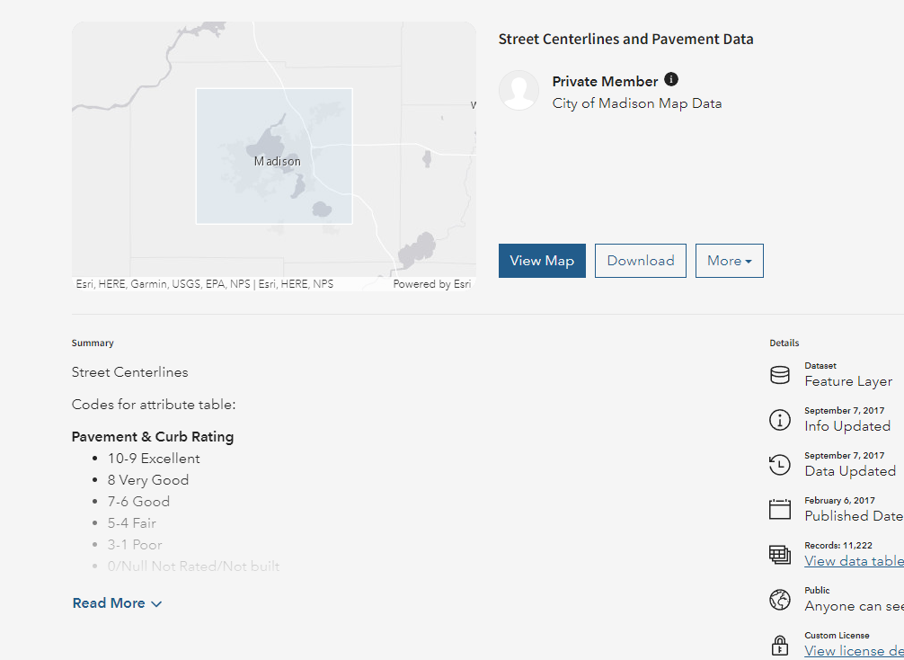

Temporary Parking Permit Program (RP3)
- RP3 parking areas, 2-hr zones.
- Only applies to driveway impacted or restricted on-street parking.
- For the temporary parking permit the following would be needed from the resident.
  - Full address.
  - Confirmation of address (this could be a utility bill or driver’s license).
  - License plate information of the car which the permit would be issued for.
  - The documents can be submitted as a reply to the email.
- Forward resident reply to parking@cityofmadison.com.
- Per must pick-up permit @109 MMB.
- It needs to be picked up at the parking office as the clerk will brief them on the instructions of the permit.
- Cost of permit – none.
- A permit is required per car that is expected to park in those adjacent streets of the project. If there is a case that, for example, if a house is composed by 3 housemates, they each need to get their own permit and they each need to provide proof of address.
- A permit cannot be used in multiple cars and can only be used to park on streets within specific RP3 Zone.
- The permit is only valid for a period of time. A general guidance would be to use the project schedule as a guideline, consider adding a 1 week of to the permit incase the project finish beyond the completion date.
  - If there is the case that the construction is expected to end after the expiration of the permit, the Design Engineer to send a email to parking@cityofmadison.com for them to issue new permits and contact the residents to pick up the new permits.
- Design Engineer to check that the documents are in order and forward the information provided by the resident to parking in case they need to double check any information.
- Point of contact: Scott Briggs, Parking Utility, sbriggs@cityofmadison.com.

Consultant Contract Amendment & Municipal Agreements
- A resolution has to be created.
- Introduce at CC, BPW, CC.
  - If the contract amendment includes a budget amendment, introduce at CC, then BPW, then finance committee, then back to CC.
- When there are signed agreements between consultants and municipalities, the Design Engineer has to initiate the signatures after CC approves.
- Be aware of contract end dates. Amendment may be required to extend contract, which must be done and approved by CC before the contract expires.

