Steps to adding Paid Leave to Timesheet.

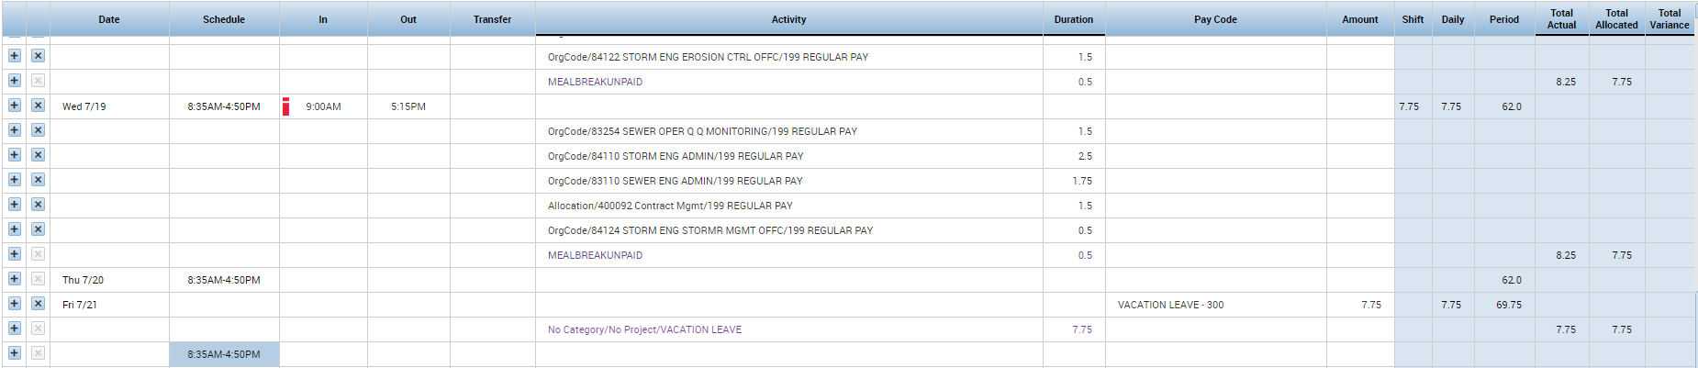
3.
2.
1.

- Click “+” to add line to the day you are using paid leave. If you do not have any punch in/out for the day, you do not need to click”+” and just go directly to Step 2.
- Select the paid leave you will be using by clicking the cell in Pay Code column for the day you want to enter the paid leave. A drop down field will appear and you will either scroll or type what paid leave you are using in the search box.
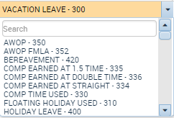
- Enter the amount of hours in the Amount Column. Based on your Comp Group, you will need to enter the amount to add up to 7.75/day, 38.75/week or 77.5/period.

Remember to click save.

Any questions please contact Kong Vang or Jennifer Wright.

