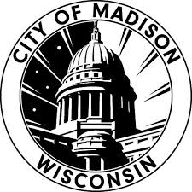
#TEAMCITY
EMPLOYEE NOMINATION FORM
Nominations are now being accepted for City of Madison’s #TeamCity employee recognition! Submissions are accepted on a rolling basis. This is Our Madison: Inclusive, Innovative & Thriving. You may nominate any City employee from the organization. Eligible employees include: full-time, seasonal, hourly, limited term employees, and interns. Please follow these criteria when identifying a nominee:
We value equity; civic engagement; well-being; shared prosperity and stewardship. We are on a mission to provide the highest quality of service to our residents and visitors. Winners of this award will:

- Serve coworkers and members of the public in a kind and friendly manner.
- Listen actively and communicate clearly.
- Involve those who are impacted before making decisions.
- Collaborate with others to learn, improve and solve problems.
- Treat everyone as they would like to be treated.

Support the goals outlined on
- Madison’s Racial Equity & Social Justice Initiative (RESJI)
- 7 Elements of a Great City & Performance Excellence
- Madison’s 100% Renewable Madison Plan

Please use this form to tell us the story of this outstanding individual’s accomplishments for the City of Madison.

Please submit this nomination, or questions, to iuludag@cityofmadison.com or mail the form through inter-departmental mail to Ilknur Uludag at Fleet (4151 Nakoosa Trail).
We will reach out if the nominee is selected, and provide ceremony details.
***
Your Name & Title: Click or tap here to enter text.
Nominee Name & Title: Click or tap here to enter text.
City Department: Click or tap here to enter text.

Nominee’s current responsibilities:
Click or tap here to enter text.

Why should this individual receive the award? For instance, are there any projects that support this nomination?
Click or tap here to enter text.

Relevant education and career history (City & non-City) (optional):
Click or tap here to enter text.

Any other supporting information (optional):
Click or tap here to enter text.

