# Logo AI-generated content may be incorrect.General Journal Entry

The General Journal Entry/Proof program allows you to enter a manual general journal entry, update the entry, proof the entry, and release the entry for approval and posting. Descriptions of the fields within the General Journal Entry/Proof program are listed at the end of this document.

Use the following steps to create a manual general journal entry:

1. Open the General Journal Entry/Proof program.  
   *Financials > General Ledger Menu > Journal Entry/History > General Journal Entry/Proof  
   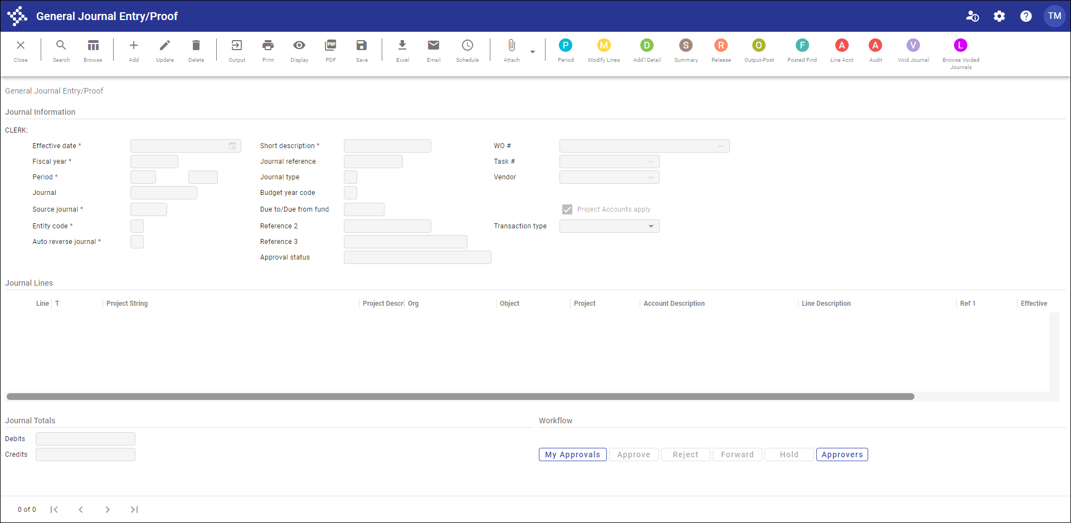*
2. Click Add.
3. Complete the header fields to enter the manual journal. Press **Tab** to move through the fields. Once you complete the header information, the Journal Lines group is accessible.   
   
4. Complete the fields to enter the line detail information.
5. To add detail lines, press **Tab** from the last box in a row to create a new detail line.   
   The Line Description from the previous line is the default value for a new line. Make necessary changes to default values; as you add details, the program tracks debits and credits in the Journal Totals group at the bottom of the screen.
6. Click Accept when you have completed entering your journal lines.
7. Click Release to submit the journal entry into the workflow for approval.

# Header Field Descriptions

| Field | Description | Notes |
| --- | --- | --- |
| Effective Date | Specifies the date that the transaction affects programs in Enterprise ERP.  The default value is the current date, but you can change this if necessary. In certain circumstances, you can enter an effective date that is a future date.  Type a date or click the calendar button to select a date. |  |
| Fiscal Year | Identifies the fiscal year associated with the journal entry. This field is assigned using the year entered in the Default Year/Period boxes in the General Ledger Settings program. This is a required field. Type the fiscal year in the YYYY format. |  |
| Period | Indicates the period within the fiscal year associated with the journal entry. The default value for this period is the value of the Default Year/Period box in the General Ledger Settings program. When you are adding data, you can enter a different period if you have appropriate permissions. Period is part of the journal key for all general ledger transactions.  If the default period does not match the effective date, those with the necessary permissions see a warning message and the period is updated automatically to the current period. Those who do not have permission to change the default period are warned that the effective date and period do not match, but the period does not change and entry must be made to the original default period. |  |
| Journal | Displays an automatic sequential number based on the numbering system set up in Journal Number Control. The program completes this number and you cannot change it. |  |
| Source Journal | Identifies the source of the journal you are entering. A general journal entry source is typically GEN for general or GCR for cash receipt.  If the value is GCR and the fund is a revolving fund, the program updates the following fields in Account Master: Revised Budget (CY), Budget Transfer In (CY), Budget Transfer Out (CY), and Last Updated. If the fund is also a multiyear fund, the program updates the value of the Inception Revised Budget field. |  |
| Entity Code | Indicates how Enterprise ERP is shared between two locations (such as a town and a school):  1 - First entity only  2 - Second entity only  3 - Always shared  Entity codes are established in the System Settings program, which is available from the System Administration menu.  If your organization uses entity codes, you must select an entity code. |  |
| Auto Reverse Journal | Designates the journal as an Auto Reverse Journal (an accrual journal entry), indicating that this journal is to be included when you select the Auto Reverse option in the Journal Reversal program. The default value is N - No.  Type Y (Yes) to identify this journal as an auto reverse journal. |  |
| Short Description | Contains the user-defined journal reference. Enterprise ERP programs use this description on screens and reports where journal information is summarized. It occupies the Ref 4 position. This is a required field. |  |
| Journal Reference | Specifies the user-defined journal reference code that stays with each transaction throughout its life. It may be a control number, a date, or a note.  The journal reference from General Journal Entry/Proof occupies the Ref 1 position on inquiry screens and reports. Entries in the Reference 2 and Reference 3 boxes display in Ref 2 and Ref 3 on screens and in reports. The short description occupies the Ref 4 position on inquiry screens and reports.  Information in reference fields varies depending on the program in which the journal is created. For example, if the journal was created during Invoice Entry, it may contain the vendor number. |  |
| Journal Type | Indicates the type of journal. The default value for this box is blank, but you can add a type code. There are three typical journal type codes: Normal (N), Interfund (I), or Adjustments (A). If you consistently assign type codes, they may be used as search criteria in queries and reports.  If the default value for this box is “~” and the value of the Source Code box is GCR, this is an imported journal and you cannot change the type code. |  |
| Budget Year Code | Identifies the budget year code, which can be either 1 for Current Year or 2 for Carry Forward. This box can only be changed from the default of 1 if the value of the Budget Carry Forward Method option in the General Ledger Settings program is 3–GAAP/Budgetary Combined. Setting this option to 2–Carry Forward adds the gross amount of each transaction to the Carry Forward from Last Year Actual field in Account Master. (It codes the entry as related to last year's budget so it can be excluded from a current year budget report if desired.) |  |
| Due-to/Due-from Fund | Identifies the target fund to use when you are generating due-to/due-from accounts. The default value for these boxes is the due to/due from fund selected in the User Attributes program, but you can change this.  **Note:** Due-to/due-from accounts must be created in the Due To/Due From Setup program. |  |
| Reference 2, 3 | Offer the option for entering more detailed information. The values entered display on screens and reports. Each box contains up to ten characters. |  |
| Approval Status | Indicates the current approval status of the entry. If your organization uses Enterprise ERP Workflow, the program updates this value as the approval process progress. A journal that is initially entered has a status of Held until approved by a designated approver. |  |
| WO # | Specifies the work order to which the journal applies. If you enter a work order number, the program creates actual supply detail lines for that work order.  This box is applicable if your organization uses Tyler Asset Maintenance. |  |
| Task # | Contains the task number or code to which the journal applies. You must enter a task in this box.  This box is applicable if your organization uses Tyler Asset Maintenance and you have entered a work order number. |  |
| Vendor | Identifies the vendor assigned for the work order and task specified. Type a vendor number or click the field help button to select a vendor from a list of available vendors.  This box is applicable if your organization uses Tyler Asset Maintenance and you have entered a work order number. |  |
| Project Accounts Apply | Indicates that project account strings apply as part of the journal entry, if selected. |  |
| Transaction Type | Indicates how the journal transaction was made: by adjustment or by wire transfer. Select the blank option to omit this value.  This information appears in the thirtieth position of the comment field when the journal is posted. |  |

Line Detail Field Descriptions

| Field | Description | Notes |
| --- | --- | --- |
| Line | Assigns the line number of the journal entry. The program completes this number; there is no access to this field. |  |
| T | Indicates whether the line is for an expense or funding source string, if the journal entry applies to a project from the Project Accounting module. |  |
| Project String | Provides the project string to which the entry applies. Click the field help button to select a string from a list of available options. |  |
| Project Description | Provides the name of the selected project string. |  |
| Org Object Project | Indicate the org, object, and project codes for the general ledger account. |  |
| Account Description | Provides the account description from the Chart of Accounts for the selected general ledger account. |  |
| Line Description | Contains the user-defined description for the individual line posting. The description can contain up to 30 characters. |  |
| Ref 1 | Specifies the user-defined short description of the posting for the individual journal line. The description can contain up to 10 characters. |  |
| Effective Date | Indicates the date the transaction affects the general ledger. |  |
| D/C | Identifies if the line is a debit (D) or credit (C). |  |
| Amount | Specifies the amount of the transaction. This should be a positive number. Zeros and negative numbers are not accepted. For this value, the program checks the available budget for expense accounts. The program displays a warning if it detects an over-budget entry; it allows you to continue if you have permissions to make over-budget entries. If you are not authorized to enter over budget amounts, the program does not all you to continue without entry of a supervisor password. |  |