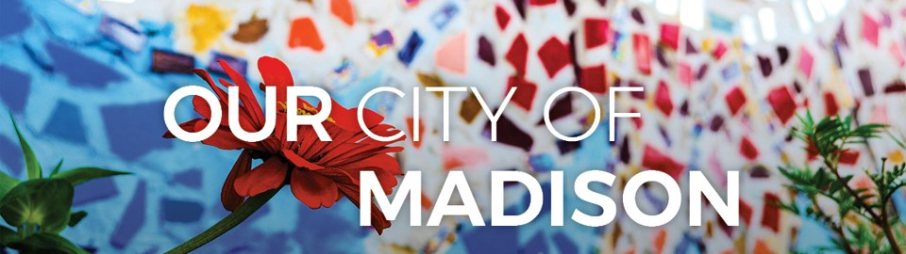

TeamCity Change Leadership
Exploring Organizational Change Readiness with Your Team
Instructions: Use this worksheet as a guide to continue exploring the change environment in the City and in your agency. Complete the Organizational Change Readiness Assessment (OCRA), have others on your team complete the OCRA, and explore some of the questions below. Note: you may want to calculate two OCRA scores – one for the City as a whole and another for your agency.
Think about the City’s or your agency’s OCRA results as you explore the following questions:
- What is the overall change readiness level of the City and your agency? What are the implications of this level of readiness on your team members’ openness to innovation, new ideas, change?
How different is your agency’s change readiness score from the change readiness score you calculated for the City?

- Which OCRA dimensions represent areas of strength for the City or your agency that might help facilitate change acceptance among your team?
How might the City or your agency best maintain or continue its investment in this strength?

- Which OCRA dimensions represent areas of vulnerability for the City or your agency that might undermine change acceptance among your team?
What actions could the City or your agency take to address these vulnerabilities and help support greater change readiness?

TeamCity Change Leader Actions to Support/Strengthen Change Readiness
Based upon the OCRA results for the City and your agency and discussions with your team, what actions might you take in your formal or informal leadership role to (1) enhance and strengthen change readiness within your team and (2) help strengthen the City’s or your agency’s change readiness infrastructure?

