This document is intended to serve as a guide for having conversations about evolving work culture across the organization. It can be used by supervisors in 1:1s and with teams and among peers to begin dialogue on how we want to be together as we provide public services on behalf of the City of Madison.

What this discussion guide is | What this discussion guide isn’t
A conversation guide for work culture to be used within teams and among peers. | An answer to what TeamCity work culture looks like.
A means to envisioning a future state those involved in the conversation seek to create. | How we hold ourselves accountable to achieving the future state.
A tool for staff across the entire organization. | A tool for only “good” managers to use with staff.
A means to creating supportive staff culture. | A way to use new norms against each other.

What is Work Culture? Work culture is the set of attitudes, values, expectations, and practices that guide and inform the actions of team members.
Why are we issuing this guide? An organization's work culture defines acceptable ways to behave within the organization. With lessons learned in the last year of continuous change, we have an opportunity to redefine our work culture to support staff in the future. We often make assumptions about these things. This is our opportunity to explicitly define, document, and hold ourselves accountable to the work culture we seek to create. The consequences of not doing so may lead to lowered morale, staff burnout, issues with staff retention on interdisciplinary teams, and ultimate turnover across the organization.
Step 1: Set Intentions and Ground Rules
State intentions for having this conversation. For example, review the above “Why are we issuing this guide?” and add a personal intention highlighting why this important to you.
Set clear ground rules. Consider starting with the list below. Be sure to crowd source from the team what they would add or change.

Step 2: Review and Affirm the City’s Vision, Mission, Values, and Service Promise
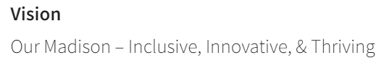
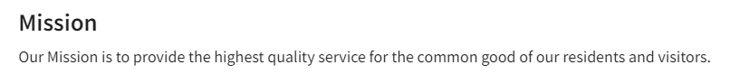
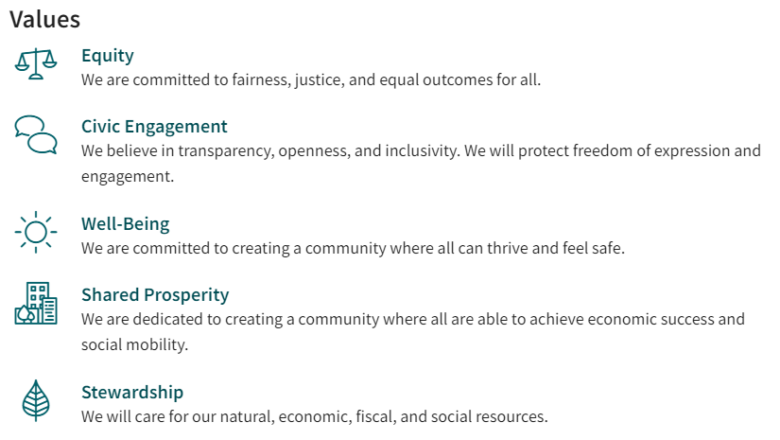
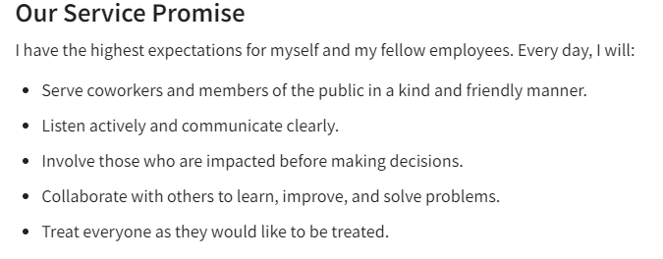

Step 3: Begin Discussion
We learned a lot over the past year about being nimble to act on what matters most. With our goal of living our values, what do we want to start, stop, and continue doing in order to achieve the vision of Our Madison: Inclusive, Innovative, & Thriving when we are at work?
Use the following table to document your discussion.
Start  What do we want to start doing? | Stop  What do want to stop doing? | Continue  What do we want to continue doing?

Step 4: Holding Ourselves Accountable
In order to make these discussions meaningful we must be disciplined on our implementation.
- How will we check ourselves around our efforts to improve?
- How often will we come back to the things we agreed upon?
- How will we approach each other if what we discussed and agreed upon is not what we see happening around us?
Questions? Please reach out to Karalyn Kratowicz, Performance Excellence Specialist

Example: Sample Stop, Start, Continue
The example documents conversations between telecommuting staff in 2021 as offices were reopening.
Start  What do we want to start doing? | Stop  What do want to stop doing? | Continue  What do we want to continue doing?
Provide in-person customer service again.  Be intentional about why we come to the office and how we use space.  Schedule pop-up co-working days in an empty conference room.  Document “lessons learned” so we can keep improving.  Explore ways to make underused office spaces able to be reserved.  Share calendars within our team.  Cross-train staff to allow for job rotation and resiliency.  Have consistent sick leave policies and practices.  Be outcome-based not output-based.  Do some 1-on-1 meetings off-site or go for a walk.  Check in if someone’s behavior or job performance changes suddenly.  Implement visual and digital accessibility, especially now that so much has gone virtual.  Prioritize development and growth of staff. | Making changes and decisions without communicating.  Treating flexible schedules and telecommuting as a reward.  Shaking hands.  Requiring documentation for employees to use sick leave or have their health needs accommodated.  Basing everything on a productivity model and artificial timelines.  Meetings that could have been emails.  Pretending everything’s “normal” and we haven’t experienced collective trauma.  Shouting across the office when we have a question for a coworker.  Telling people to smile.  Noise distractions in the office. (Loud conversations by people’s desks, playing music where others can hear it.) | Providing and promoting online options for customers.  Asking what employees want and need to be successful.  Basing flexible schedules and telecommuting on essential functions of the position.  Allowing employees to be creative about how they accomplish work.  Staying/ working from home if sick, even if symptoms are mild.  Using the COVID-19 Equity Questions and other equity tools in decision-making.  Clear subject lines in emails (“Action needed,” ‘FYI” etc.)  Trying new things. It doesn’t have to be perfect the first time, we can learn and adjust as we go.  Washing hands, access to hand sanitizer and cleaning supplies.  Sending a skype messages to see if someone has a moment before walking over to their cubicle/office.  Checking in about how people are feeling.  Managing employees and projects using work plans, etc.

