1:1 Agenda Template

Use the 1:1 Meeting Agenda Template on the next page to help facilitate your one-on-one discussions and increase meeting effectiveness.
The creation and maintenance of these agendas should include both Manager and Employee input, as this agenda needs to work for all parties involved!
When preparing for a 1:1, consider…
Employee:
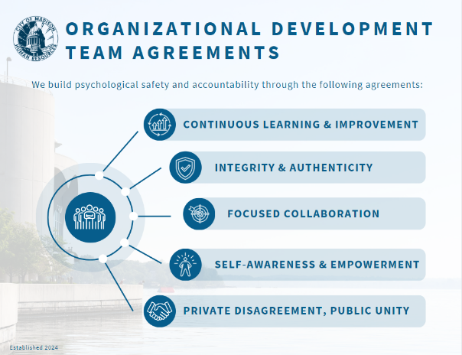
- What do you believe is important to share with your manager?
- What is something you’d like to share with your manager that they haven’t asked you?
Manager:
- Listen more than you talk. Remember the 80/20 rule: Listen 80% and talk 20%.
- Create a welcoming and safe environment for your employee.
    - Ask your employee what this looks like for them.
While having a 1:1,
- Remove distraction and focus entirely on the 1:1.
- Start by connecting on a human level.
- Acknowledge and Validate employee. (Created by the HR-OD Team).
- Avoid focusing solely on immediate tactical issues.
- Check out some examples for One-on-One Questions.
Other Items Included in the 1:1 Agenda Template:
- Cadence: To be determined between Manger & Employee.
- Purpose: This should be defined and agreed upon by the entire team, Manager + all team members.
  - Example: “Devoted time for each __unit/department name__ team member to share progress of goals, projects, successes, and challenges with __unit/department name__ Manager.
- Team Agreements: Create meaningful Team Agreements together as a team and including these with your agenda.
  - Example: “Come Prepared, Share Time, Name and Review Action Items, Use this Template”
  - Another Example: See image.
- Self-Reflection: Take this opportunity to reflect on the positive aspects of your work and how you are showing up in relation to the City Employee Core Expectations.

Looking for More Tools & Resources Like This?

Check out Organizational Development’s Toolkit, Additional Learning Resources, and Online Courses. Or, if you have a suggestion for a new resource, share it with us at OrganizationalDevelopment@cityofmadison.com.

1:1 Agenda Template
Cadence: _________to be determined between Manger & Employee__________________________________________________________________________________________
Purpose: _________to be determined by Team___________________________________________________________________________________________________________
Team Agreements: _________to be determined by Team__________________________________________________________________________________________________
Topic | Notes –Type Here During 1:1 | Action Items
Follow-Up on Action Items from Last 1:1
- List Any Here
Check-In:
- What was at least one win for you in the last 2 weeks?
- What are your priorities for the upcoming 2 weeks?
- Any schedule outages for the upcoming 2 weeks?
- Any frustrations/challenges in the last 2 weeks?
Note, above timeframes will shift depending on what cadence you set.
Self-Reflection tied to City of Madison Core Expectations – Choose one to reflect on this week.
- Service – I serve coworkers and members of the public in a kind and friendly manner.
- Communication – I listen carefully and communicate clearly.
- Teamwork – I work with others to learn, improve, and solve problems.
- Equity & Inclusion – I treat everyone as they would like to be treated.
- Stewardship – I care for the people, resources, community, and environment – that I am trusted to protect.
Work Plan Progress – Pull up your unit/department work plan and review/walk-through progress. Discuss any areas of concern/highlights.
Cross-Unit/Department Interactions – Share meaningful interactions within your unit, with other units or departments, and how those may relate to or impact City Priorities.
Manager Items – Items Manager needs to follow-up on or share with Employee

