Team Meeting Agenda Template

Use the Team Meeting Agenda Template on the next page to help facilitate your team/unit discussions and increase meeting effectiveness. The creation and maintenance of these agendas should include both Manager and Team input, as this agenda needs to work for all parties involved!
When Preparing to Use this Agenda Template:
- Save in a Shared Location: Save this template and past agendas where all team members can access and update simultaneously (i.e. OneNote or OneDrive).
- Set Expectations: To successfully implement the use of a Team Meeting agenda, set expectations for when to add agenda items, and review deadlines.
Example of how HR-Organizational Development preps for their Tuesday Afternoon meetings:
- Update/Fill-In Agenda by Noon on Tuesdays
- Review Agenda before meeting
- If unable to review notes prior to the meeting, make sure to review after.
  - Update/Fill-In Agenda by Time of Day & Day of Week: Add Discussion & Agenda Items, General Team Updates, and Upcoming Time Out of the Office.
    - Update the template to list team member names in the General Team Updates section.
  - Review Agenda by Time of Day & Day of Week: Review items to be ready to discuss during the team meeting.
  - If there are no Discussion or Agenda Items by the deadline you set, Cancel the Meeting!
    - General Team Updates should still be added, team members can review this on their own time.
During Your Team Meetings:
- Determine a Note Taker: At the beginning of each meeting, ask for a volunteer. Rotate this responsibility in your team so it is not the same person each time.
  - Notes Column: Add notes here during the meeting.
  - Decision/Action Items Column: If a decision is made, or a follow-up action is needed by a team member, add this here for easy finding.
- Take Attendance: Log who attended each week right in the agenda.
- Check-In Question: Start by connecting on a human level with a fun or reflective question of a team member’s choosing. Whoever adds this, should be the first to answer!
- Follow-Up on Last Week’s Action items: Review last meeting’s action items and check-in on the status of any follow-up tasks.
- Agenda Repair: Review the upcoming Discussion and Agenda Items – consider and/or adjust how much time is actually needed for each item, determine what items are priority to talk about first, and what items might need to move to the next meeting – in case there are more items than there is time.
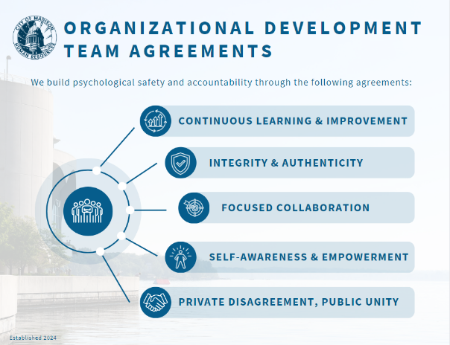
- Discussion & Agenda Items: Have the team member who added the item to lead that discussion.
- General Team Updates: If there is left-over time after all agenda items, allow team members to highlight top updates from their section if they want.
- Review Upcoming Time Out of the Office: Share awareness of folk’s out of office time and discuss coverage for tasks or meetings if needed.
Other Items to Consider:
- Cadence: To be determined between Manger + all team members.
  - If you’re planning on a daily, stand-up meeting – aim for no longer than 15 minutes. Using a template for this structure is not necessary but allowing folks to add discussion points to your agenda is recommended.
- Team Agreements: Create meaningful Team Agreements together as a team and including these with your agenda.
  - Example: “Come Prepared, Share Time, Name and Review Action Items, Use this Template”

Looking for More Tools & Resources Like This?

Check out Organizational Development’s Toolkit, Additional Learning Resources, and Online Courses. Or, if you have a suggestion for a new resource, share it with us at OrganizationalDevelopment@cityofmadison.com.

  - Another Example: See image.

Agenda – UNIT/DEPARTMENT Team Meeting
Location:
Date, Time:
Documents: | Insert hyperlinks to important, frequently reviewed documents. (I.e. work plans, budgets, tracking sheets).
Note Taker:
Attendance:
Estimated Time | Team Member | Topic | Notes  Note Taker Type Here During Team Meeting | Decision/Action Items
Meeting Set-Up
5 Minutes | All | Check-In Question & Announcements
5 Minutes | All | Follow-Up on Action Items from Last Week
3 Minutes | All | Agenda Repair
Meeting Discussion & Agenda Items
General Team Updates
 | Team Member 1
 | Team Member 2
 | Team Member 3
 | Team Member 4
 | Team Member 5
 | Etc.
Upcoming Time Out of the Office
Team Meeting Agenda Template

Team Agreements: _________to be determined by Team__________________________________________________________________________________________________

