**SUBJECT:** Mentorship Program End of Week Update

**MESSAGE:** 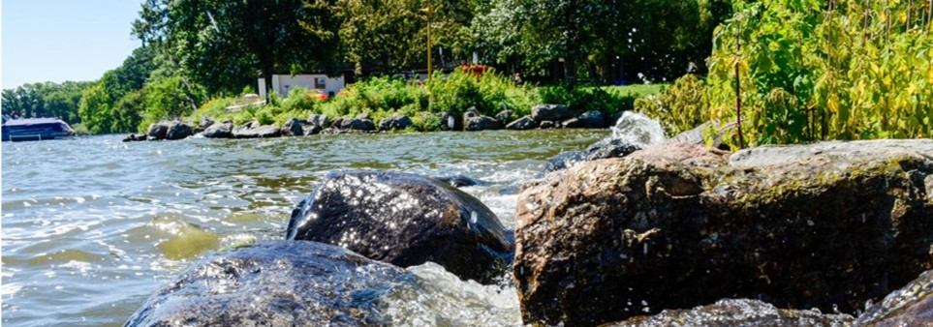

**Development Discussions & Next Steps:**

Good afternoon Beautiful People 😊

Thank you all for such a successful week of development discussions.

I appreciate the honesty, vulnerability, and courage you all continue to display. It’s a testament to the trust and safety that we have developed and will continue to nurture throughout the mentorship program.

**Check-In Survey –** *[Hyperlink Survey Monkey You Create]*

At this point, we have about [%] completion on this month’s check in survey. Thank you for taking 5 minutes to complete this brief survey to let us know how your experience has been so far. This survey is confidential yet not anonymous as I will ask for your name. Only the Organizational Development team will have access to your responses. This will allow us to best support you in real time, make adjustments, and/or intervene, only if necessary.

**Gentle Reminder:**

We will be connecting from [time on date] for our in person mid-point check in.

Thank you to [Agency] for hosting us at [Address]

Please expect a calendar invite in the coming week. 😊

As always, it’s a pleasure to support you on your journeys of growth and development.

I look forward to us being in physical community as we share success stories about how we’re growing as leaders, increasing cross-agency socialization, learning, and collaboration, and creating and promoting a sense of belonging!

See you all there!

Warm regards,

[Your Email Signature]