**SUBJECT:** PLEASE READ – Final Forecast

**MESSAGE:** 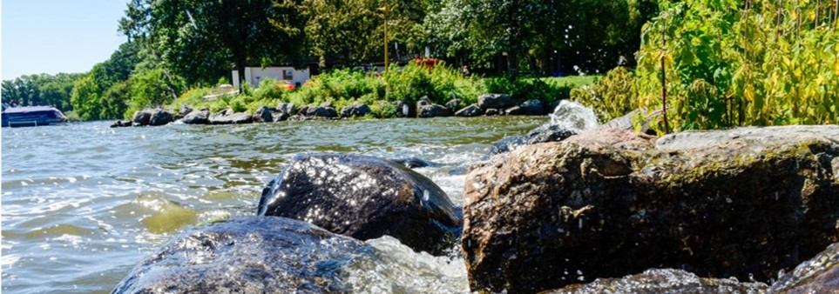

**Final Forecast – [# of Days] Days Until Celebration Time:**

Good morning,

**Mentorship Program Celebration**

I am so excited for our Mentorship Program Celebration

You will receive a calendar invite from me for **[DATE]** from **[START & END TIME]** at **[LOCATION]** (ADDRESS). Please factor in up to 30 minutes for travel time.

**Mentorship Program Celebration Request**

By **[date]** I am requesting the following be emailed to [YOUR EMAIL ADDRESS]:

1. A headshot/photo of your choosing
2. Name and pronouns
3. Agency and role
4. Final Reflection of 2-4 sentences that summarize your learning, growth, and key takeaways from the mentorship experience. This can include shoutouts to mentor/mentees/mentor groups etc.

**Final Mentor Group Meeting Agenda**

Please use the month of August to have final mentor group meetings.

Here are some things to consider in your final touch base:

* **Reflect on the Journey by r**eviewing goals and celebrating achievements
* **Provide Feedback** to each other and acknowledge each other’s contributions
* **Discuss Future Plans by** identifying next steps and if appropriate, agree on the level of ongoing support. Some mentoring relationships evolve into more informal, long-term connections.
* **Continuing Engagement by** discussing how you might stay connected, such as through occasional check-ins, invitations to relevant events, or connecting on LinkedIn. Agreeing to keep each other in mind for future opportunities, referrals, or collaborations.

**Recommended Resource(s)**

[MONTH 1] Resource: [Individual Development Plan (IDP).](https://www.cityofmadison.com/human-resources/documents/additional-learning-resources/od-toolkit/2024_Fillable_IDP.pdf)

[MONTH 2]Resource: [Skills Self-Assessment.](https://www.cityofmadison.com/human-resources/documents/mentoring-program/Fillable_SkillsSelfAssessment_Mentorship_0.pdf)

[MONTH 3]Resource: [Effective Feedback Resource Packet](https://www.cityofmadison.com/human-resources/documents/additional-learning-resources/od-toolkit/Effective_Feedback_Resources_Combined.pdf)

[MONTH 4]Resource: [Interpersonal Communication Resource Packet](https://www.cityofmadison.com/human-resources/documents/mentoring-program/InterpersonalCommunicationPacket.pdf)

It’s been a true pleasure supporting you along your mentoring journey. As always, do not hesitate to reach out for real-time support. I know you all will wrap up the mentorship program strong. I look forward to being in shared community on [date]. 😊

Warm regards,

[Your Email Signature]