**SUBJECT:** PLEASE READ_ Thank You for Attending the Mentorship Program Celebration! 🌟

**MESSAGE:** 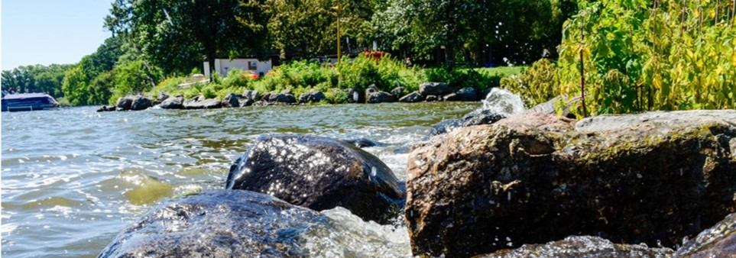

**End of Year Evaluation**

Good morning 😊

I want to extend a heartfelt thank you to everyone who joined us yesterday at [Location] for the Mentorship Program Celebration. It was truly a joy to celebrate the dedication, growth, and accomplishments of our [YEAR] Mentorship Program Cohort with you all!

As we wrap up the year, I kindly ask that you take a few moments to complete our Final End-of-Year Evaluation – *[Hyperlink Survey Monkey You Create]* by [Date]. Your feedback will help us continue to grow and improve the program for future cohorts.

Thank you once again for your time, energy, and commitment to making this mentorship journey so impactful. I look forward to staying connected and hearing more about the incredible things ahead for each of you. 😊

Warm regards,

[Your Email Signature]