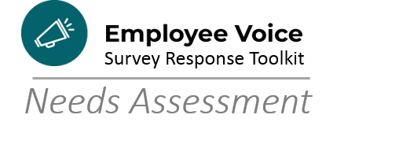

Aligning Mission/Vision/Values/Service Promise
Instructions: Read each statement and mark the box that best corresponds to your level of knowledge/experience with the topic.

 |  | Novice  1 | Advanced Beginner  2 | Competent  3 | Proficient  4 | Expert  5
1 | Knowledge of the City of Madison vision, mission, values, and/or service promise
2 | Knowledge of my department’s vision, mission, values, and service promise
3 | Understanding how my department’s work advances the City of Madison vision, mission, values, and service promise
4 | Ability to explain to my employees/colleagues how their work advances the vision, mission, values, and service promise
5 | Knowledge of the City of Madison Performance Excellence effort
6 | Ability to lead my team in a review of the mission, vision, values, service promise
7 | Regular reference to City or departmental mission, vision, values, service promise in discussion of daily work

Tally your results:

1s and 2s: _______ 3s: ______ 4s and 5s: ________

Mostly 1s and 2s: Remember that Human Resources/Organizational Development is here to support your team as you work to ensure everyone feels the connection to the mission, vision, values, and service promise in their daily work. Consider facilitating the Alignment activity in the Getting Started Guide or talk with an OD Specialist about other ways to tackle this fundamental need.

Mostly 4s and 5s: It sounds like your team has made great strides in incorporating the mission, vision, values, and service promise into everyday work. Use this opportunity to explore with your team the Connect the Work activity in the Getting Started Guide. With some added intention, you can strengthen your team’s connection to the M/V/V/SP.

Looking for more resources on . . .

Facilitating a V/M/V/SP Alignment activity
Review the video of a similar activity from the Fall 2018 Leadership Development Conference: How to Align the Vision and access the worksheets for conducting your own in the Action Plan Getting Started Guide on the Performance Excellence website.

Taking your M/V/V/SP Alignment to the Next Level
Use the Connect the Work activity in the Getting Started Guide to bring the work your team has already done ensure the alignment work becomes a part of the day-to-day work.

