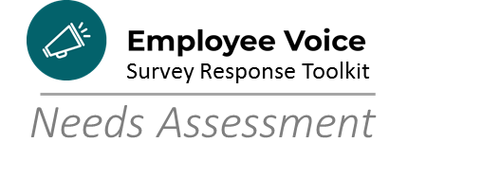

What is a Needs Assessment and why are Needs Assessments important?
A needs assessment is a systematic process for determining and addressing needs, sometimes referred to as “gaps” between current conditions and desired conditions. Needs assessment tools are helpful in measuring the need, in qualitative and/or quantitative terms, so as to provide a baseline for improvement or “closing the gap”. There is a wide range of formal and informal ways of identifying learning needs. In the case of change management, a needs analysis can be play a fundamental role in initiating and managing change, both individual and organizational.

What are examples of needs assessments?
Methods of needs assessment can be classified into seven main types, each of which can take many different forms in practice. As you begin the process of analyzing data and forming a team to develop your Employee Voice Survey Action Plan, consider whether one or more of the following may have applicability in your short- or long-range planning.

Gap or discrepancy analysis
This formal method involves comparing performance with stated intended competencies—by self assessment, peer assessment, or objective testing—and planning interventions accordingly.

Reflection on action and reflection in action
Reflection on action is an aspect of experiential learning and involves thinking back to some performance, with or without triggers (such as videotape or audiotape), and identifying what was done well and what could have been done better. The latter category indicates an opportunity for intervention.

Reflection in action involves thinking about actual performance at the time that it occurs and requires some means of recording identified strengths and weaknesses at the time.

Self assessment by diaries, journals, log books, weekly reviews
This is an extension of reflection that involves keeping a record of experiences.

Peer review
It involves team members assessing each other's work and giving feedback and perhaps advice about possible education, training, or organizational strategies to improve performance.

Observation
In more formal settings team members are observed performing specific tasks that are be rated by an observer, either according to known criteria or more informally. The results are discussed, and learning needs are identified. The observer can be a peer, a senior, or a disinterested person if the ratings are sufficiently objective or overlap with the observer's area of expertise (such as communication skills or management).

Practice review
A routine review of organizational documentation (e.g., notes, charts, work orders, policies, requests, ordinances, requests), can identify opportunities for improvement, especially if the focus is on quality and/or performance.

Auditing
- Process audit
A process audit is an examination of results to determine whether the activities, resources and behaviors that cause them are being managed efficiently and effectively

- Document audit
A document audit is examination of documentation that supports business activities, with attention to consistency or compliance, for example

- Critical incident review and significant event auditing
A critical incident or significant event audit is a formal analysis of incidents with implications for customer care in order to improve services

Adapted for City of Madison use from: https://www.ncbi.nlm.nih.gov/pmc/articles/PMC64520/

Ready to Get Started?
Before you jump headlong into the Employee Voice Survey Action Plan, it can be helpful to know where you’re starting. The following Needs Assessments can help you gauge your capacity and skill levels so that you know where to turn for resources:

- Reflection Questions
- Ethical Data Use
- Aligning Mission, Vision, Values, Service Promise
- Understanding and Responding to Data
- Creating Employee Voice Survey Action Plans

- GO TO Employee Voice Survey > Employee Voice Survey Action Plan Toolkit > Department Needs Assessments

