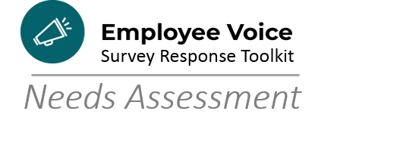

Understanding and Responding to Survey Data

 |  | Novice  1 | Advanced Beginner  2 | Competent  3 | Proficient  4 | Expert  5
1 | Interpreting quantitative data results
2 | Determining statistical significance
3 | Using benchmarks to guide goal selection
4 | Communicating about data, in general
5 | Communicating about how data informs goal selection
6 | Communicating about data visually
7 | Convening a team of people with data skills
8 | Gathering more information to inform Employee Voice Survey Action Plan, such as focus groups
9 | Incorporating data discussions into team meetings

Tally your results:

1s and 2s: _______ 3s: ______ 4s and 5s: ________

Mostly 1s and 2s: Trainings: As the City of Madison moves to more data-informed processes, we are sure to see more trainings, resources, tools, and guidance from experts throughout our organization on how to understand and respond to data. In the interim, be sure to draw from your team’s experiences with Results Madison, the Comprehensive Plan, and budgeting work. You likely have people and processes already in-place to address analytics questions.

Mostly 4s and 5s: You clearly know that cultivating a data-informed organization is a powerful way to make things happen in the City of Madison. Keep your eyes out for Centers of Excellence talks and panel discussions to stay up-to-date on best practices. Odds are good that your team may be tapped to share their successes in those very sessions!

