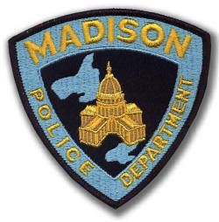
MADISON POLICE DEPARTMENT

APPLICATION FOR CIVILIAN RESPONSE TO ACTIVE SHOOTER (CRASE) TRAINING

Date:

Requester’s Name & Title: Click here to enter text.
Phone Number: Click here to enter text.

E-mail Address: Click here to enter text.

Business/Organization: Click here to enter text.

Address of Business/Organization: Click here to enter text.

Within City of Madison? No Yes

Date(s) on which you would like to conduct the training: Click here to enter text.

Expected number of attendees: 1-24 25-49 50-74 75-100 100+

Do you have a location where this training can take place? No Yes

Training requested (with required time needed for instruction):

Lecture – mandatory (2 Hours) Medical (1 Hour)

Defensive Tactics (1 Hour) Security Walkthrough (1 Hour)

Any additional notes: Click here to enter text.

How did you hear about us: MPD Website Media Other_____________________

