Contents
Overview: The Employee Voice Survey Action Plan 2
Action Plan Definition 2
Benefits of an Action Plan 2
The Employee Voice Survey Action Plan Template 3
How to Use this Getting Started Guide 4
Getting Started Guide Activities 4
Foundation Work: Mission, Vision, Values, Service Promise, and the 7 Elements of a Great City 4
Aligning the Vision, Mission, Values, and Service Promise 4
Connecting the Work 6
Brainstorming within the City-wide Goals 7
Scoping the Work 8
Prioritizing Action Items 9
Mapping Priorities on a Timeline 9
Building S.M.A.R.T.E. Goals 10
Assigning Roles with RACI 11
Creating Your Action Plan 11

Overview: The Employee Voice Survey Action Plan

Action Plan Definition
Action Plans are written documents that guide the work of a team.

Benefits of an Action Plan

People-centered Results | Ensures the best outcomes for City of Madison residents through the best use of resources and most strategic use of staff time
Employee Engagement | Helps make sure responsibilities are equitably dispersed among staff members based on work load, interest, and skill
Teamwork | Sets clear expectations for all team members which helps increase communication, role clarity, and teamwork
Accountability | Creates an environment of transparency and clarity about individual and group responsibilities, increase chances people will do what needs to be done
Scoping | Helps to scope work and create realistic goals. Also helps communicate and set realistic expectations for policymakers and managers
Connection to Purpose | Ensures your agency and work unit are aligned with citywide priorities

The Employee Voice Survey Action Plan Template
The City of Madison has adopted a simple Excel spreadsheet template for its Action Plan format. Each column in the Action Plan corresponds to a meaningful piece of information that answers crucial questions about how, when, by whom, and when steps will be carried out.

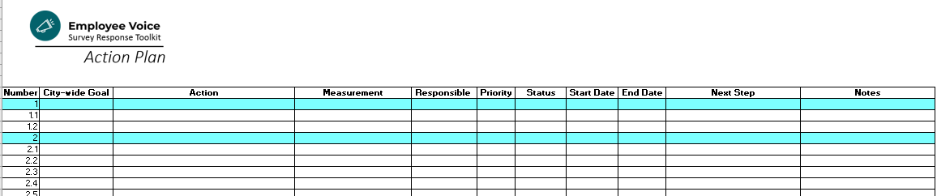

The Action Plan template includes important resources in the tabs:
- Overview tab (1)
Provides background information and links to the Employee Voice Survey Toolkit
- Instructions tab (2)
Defines each column and provides helpful Tips about completing the Action Plan
- Action Plan tab (3)
Contains formatted fields for you to complete and upload to Sharepoint by May 1, 2019
- Take Action tab (4)
Lists potential Next Steps for you and your team, to move from plan to action
- Prepping for Consulting tab (5)
Links to the Consulting sign-up page and gives in-depth details on how best to prepare for your time with a Human Resources Consultant.

How to Use this Getting Started Guide
After you have 1) completed any Needs Assessments you elected to take and 2) previewed the Action Plan template, we encourage you to use this Getting Started Guide in ways that best benefit you and your team. This workbook is intended as a companion guide to your Action Planning process, not as a requirement. You will not submit the Getting Started Guide on May 1, so it is entirely yours/your team’s to use as you see fit. There is no “right” or “wrong” way to prepare for writing your Action Plan.
The workbook is organized so that activities build upon one another, helping to move you from abstract brainstorming to formal, actionable plan steps. This format is perfect for the organization looking to build capacity in both formal and informal leaders. The guidance provided in the workbook, coupled with your mentorship (and perhaps that of other City teams tightly coupled to Performance Excellence - Human Resources, Finance, IT, for example), can serve as a support structure for emerging leaders to gain experience shepherding ideas from “raw data” to implementable plan.
The activities contained in the Getting Started Guide can be also used with your teams as stand-alone exercises. On average, the exercises are timed at about 60 minutes each, although length will vary based on the amount of pre-work, experience of participants, and other organizational variables. Rest assured that there will be natural starting- and stopping-points so that you can spread activities across several team or group meetings, retreats, Engagement team or management team sessions. Keep in mind that many of these tools have been taught in Supervisor Development, Leadership Development Program, and other Human Resources training sessions. This is a great opportunity to tap into your team members and have them bring their subject matter expertise to bear on the Action Planning process.
Remember: These activities are most definitely great examples of Employee Engagement and may be excellent Action steps in and of themselves. They involve employees being more connected to decision-making, communications, and lead to better understanding of how their jobs matter.

Getting Started Guide Activities

Foundation Work: Mission, Vision, Values, Service Promise, and the 7 Elements of a Great City

Aligning the Vision, Mission, Values, and Service Promise
The City of Madison Vision, Mission, Values, and Service Promise should be at the very foundation of every action we take. Whether as a precursor to creating your Action Plan or as a step within it, it is wise for agencies to ensure that their services (connected to the 7 elements) align with the desired future (vision), how they will advance to the vision (mission), values (the priorities used in decision-making), and the commitment we make to the community (service promise).
Instructions: Add ideas for each category on the left side of the chart, either as a brainstorm or using current mission, vision, values, service promise. You can complete this activity individually or in groups or pairs, but the key is to bring together diverse perspectives to ensure that the team feels part of the experience of connecting the work to the mission, vision, values, and service promise. Remember to revisit your Results Madison services list to ensure that you pull forward work you’ve completed in 2018.
Compare your agency’s to those of the City and see where yours correspond and where you may need to strengthen ties to the City’s. If your team has not revised its mission, vision, values, and service promise recently, recognize that the exercise may last several weeks of months, perhaps requiring a project team to guide the process to completion.
My Agency | The City of Madison
Vision - lays out the desired future | Vision
 | Our Madison – Inclusive, Innovative, & Thriving
Mission - describes how we will advance to Vision | Mission
 | Our mission is to provide the highest quality service for the common good of our residents and visitors.
Values - used in decision-making | Values
- Equity
- Civic Engagement
- Well-Being
- Shared Prosperity
- Stewardship
Service Promise - commitment we make to residents and employees of the City of Madison | Service Promise
I have the highest expectations for myself and my fellow employees. Every day I will:
- Serve coworkers and members of the public in a kind and friendly manner.
- Listen actively and communicate clearly.
- Involve those who are impacted before making decisions.
- Collaborate with others to learn, improve, and solve problems.
- Treat everyone as they would like to be treated.

Agency Services - connect everyday work of employees to the Vision, Mission, Values, Service Promise | Elements of a Great City
Effective Government
Economy & Opportunity
Green & Resilient
Culture & Character
Land Use & Transportation
Health & Safety
Neighborhoods & Housing

Note: A similar session, titled Aligning the Vision, was facilitated at the October 2018 Leadership Development Conference. Check out the video on the Performance Excellence webpage > Resources > More Performance Excellence Meetings to get facilitation ideas and build your team’s capacity for conducting a similar session for your own agency.

Connecting the Work
Once your mission, vision, values, and service promise are finalized, it’s time to anchor them into our daily work. Use the Connect the Work activity to brainstorm ways in which you make the mission, vision, values, and service promise come to life.
- It starts with making Performance Visible. Where, in our physical space, can we make it visible?
- It continues and becomes more nuanced when it is Discussed. Where are opportunities to discuss?
- It goes deeper when it is Acknowledged as a part of our work. What measures will show that we’ve achieved success?
- When we do it well, it is Rewarded in our community. How do we celebrate individuals and as a team?
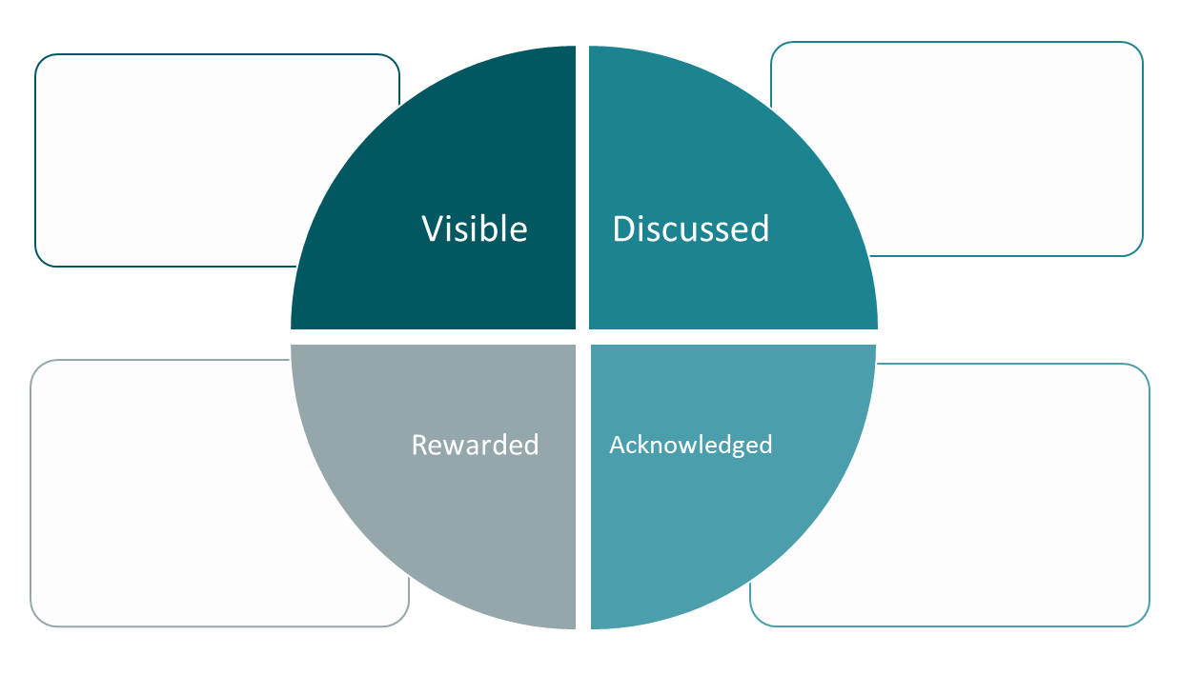
Instructions: Brainstorm answers to the questions above and consider how these Action steps fit into your larger Employee Engagement, Employee Development, and Communication goals in the Action Plan.

Brainstorming within the City-wide Goals
With any survey, raw data is just the beginning of the journey to action. One classic technique for incorporating the data with real experience, stories, qualitative data, existing action steps/plans is in the form of a Start-Stop-Continue exercise.
Instructions: Use this worksheet to organize the brainstormed goals you’ve gathered from the Employee Voice Survey Report data, other plans (e.g., Results Madison, Equity Plans, Sustainability Plans, Comprehensive Plan), and most importantly, from the focus groups, meetings, and discussions you’ve had within your agency. Once you’ve collected the information, it’s time to see which are the most prevalent, important, or urgent. These are the seeds for your Action steps.
Tip! Conduct this exercise as a main activity in small group “information gathering” sessions like focus groups, briefing discussions, leadership retreats, team meetings. Adapt it to a large group with color-coded sticky notes or poster paper and markers. In the session, create a safe space for people to share their ideas in responsible ways.
Continue
Engagement | Employee Development | Communication
Continue: Other

Start
Engagement | Employee Development | Communication
Start: Other

Stop
Engagement | Employee Development | Communication
Stop: Other

Scoping the Work
Odds are good that with 40+ pages of Employee Voice Survey data, your Department Report, past employee surveys, engagement activities, and concurrent planning activities, your team has generated quite a few ideas that align with the City-wide goals of building on Employee Engagement, Employee Development, and Communications.
Some action steps and goals will rise to the top of your list quite naturally – everyone agrees that they are urgent, important, actionable, and enjoy broad support. Even if you do agree on many of them, you may still have too many to reasonably pursue in the short term. And what about those that are more ambiguous? How do you determine which to tackle now, which to address later, and which do not offer enough return on investment to pursue? A simple Scoping Tool can offer a more objective view.
Instructions: Complete the chart below as a team OR have individuals complete the scoping tool individually and compare answers to narrow down specific decision points. Use one chart per individual Action item or project and consider adding, adapting, or removing questions to better meet your agency’s needs. This activity is best utilized with the ambiguous Action items that have not emerged as clear “yes” or “no” Action items.
Description of the project, request, goal, action, or proposal:  Why did this request arise?  Timeline - including start and end date (or indicate if ongoing): | Yes | Unsure | No | Notes
- Does it align with the agency’s mission and goals?
- Is our involvement required by policy or current work plan goals?
- Is our involvement requested by upper management, Mayor, Common Council or the head of another City agency?
- Is there information or evidence to suggest a need? (What is it?)
- Are there ways to measure impacts related to this?
- Does this build on or connect with existing efforts?
- Is there existing capacity to take this on at this time?
- Are we aware of existing efforts related to or supporting this? (e.g., if we don’t take this on, is there someone else who can?)
- What are the objectives or expected outcomes?
- What are the limitations (external, internal, financial, and political)?

Prioritizing Action Items
Another classic prioritization tool is a 2x2 Urgency vs. Importance square.
Instructions: Plot your Action items to help determine the priority level of the item (More or Less Important) and the possible timeline for completion (Urgent, within the next 6 months or Less Urgent (6 months to a year or longer).
 | Urgent (within the next 6 months) | Less Urgent (6 months to a year or longer)
More Important
Less Important

Mapping Priorities on a Timeline
Instructions: Track your priorities on the simple timeline below, or build your own on a whiteboard, poster paper, or software program like Microsoft Office Timeline (PowerPoint plug in).

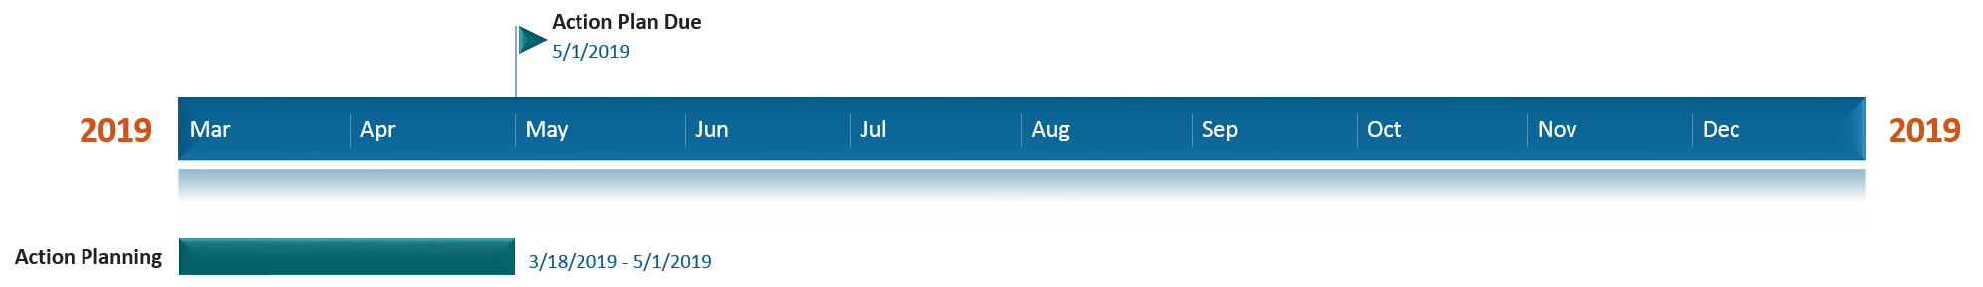

Building S.M.A.R.T.E. Goals
Once you have prioritized and grouped your Action items, it’s time to add greater detail so that we can hold ourselves and our team accountable to completing them. Want to move quickly into Action Planning? Master the art of S.M.A.R.T.E. goal-setting and you’ll have 90% of your work done before you even open the Excel file.
S.M.A.R.T. is a mnemonic/acronym, giving criteria to guide in the setting of objectives, for example in project management, employee-performance management and personal development. One of the City of Madison’s values is Equity, so we have added the final “E” in S.M.A.R.T.E. to remind ourselves that we are not done with decision-making or goal-setting until we have continued the equity implications of our choices.
Instructions: Take your synthesized list of goals and Action items and consider the items that hang together a “priority” or “category”. Each major priority should be identified with a whole number; each strategy or action step toward that priority should be identified with decimals, with as many sub-items as needed to address the overall priority.

- S.M.A.R.T.E. Goal Priority/Category 1

- S.M.A.R.T.E. Goal Priority/Category 2

- S.M.A.R.T.E. Goal Priority/Category 3

- S.M.A.R.T.E. Goal Priority/Category 4

- S.M.A.R.T.E. Goal Priority/Category 5

Assigning Roles with RACI
While the Action Plan only asks for the Responsible party, with agency-wide actions, it’s a smart idea to consider how other team members may be involved in making decisions and getting the work done. The RACI (sometimes called a RACI Matrix) is a standard project management tool that defines who is Responsible, Accountable, Consulted, and Informed. This assignment goes a long way toward strengthening team dynamics because when roles are clear and expectations well communicated, we are better able to support each other and hold each other accountable.
R | Responsible  The person who is assigned the task
A | Accountable  The person who makes the final decision, who has ultimate ownership
C | Consulted  The person who much be consulted before the decision is made
I | Informed  The person who must be informed that a decision has been made

Creating Your Action Plan
When you are ready, be sure to download a copy of the Action Plan from the Employee Voice Survey website and get started completing the Action Plan tab.
Remember to use the tools built into the surrounding tabs, including easy Upload when you’re ready to submit and Scheduling links for Consultations with HR Analysts or Organizational Development Specialists.
If you get stuck or need a boost, remember that Human Resources / Organizational Development is happy to support you any time. Just email us at OrganizationalDevelopment@cityofmadison.com and we’ll find a solution that helps put you back on-track for success.

